BODY OF CHRIST CHURCH PRESCHOOL APPLICATION



Tonya Dunn
Director,
872-1391 x112

ENROLLMENT CHECKLIST FOR PRESCHOOL

Name ___________________________________________________________ Age_________________

Date Enrolled ____________________________________________________

Division of Child Development Preschool Forms checklist (✓) date)

3. Child’s Application for Child Care ______________
4. Children’s Medical Report ______________
5. Immunization History ______________
6. Discipline and Behavior Management Policy ______________
7. Travel and Activity Authorization & (permission to play outside fenced area ______________
8. Receipt of Summary of NC Laws and Rules ______________
9. Summary North Carolina Child Care Law and Rules (Parent Copy) page 1 ______________
10. Summary North Carolina Child Care Law and Rules (Parent Copy) page 2 ______________

Body of Christ Church preschool Forms Checklist (✓) date)

11. Health Information and Development History Form ______________
12. Social Relationships ______________
13. Discipline Procedures ______________
14. Parental Support& Agreement Form ______________
15. Photograph Consent Form & Mission Statement ______________
16. Authorization Agreement for Pre-Authorized Drafts ______________
16. What to bring on the first day of Preschool ______________

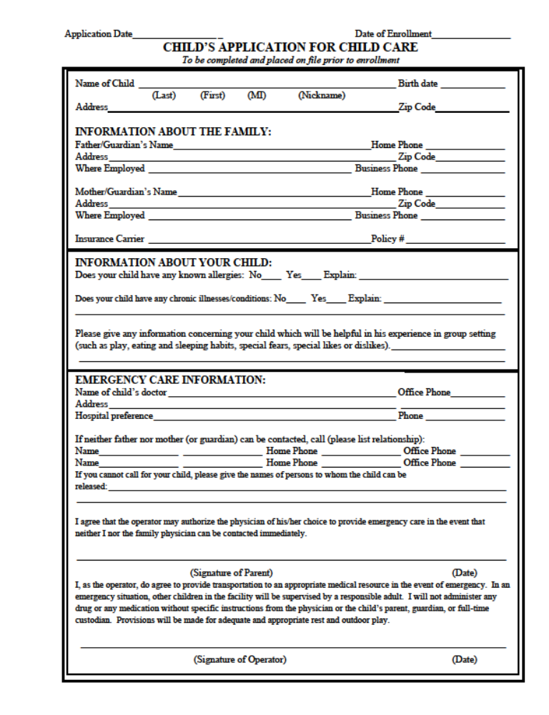
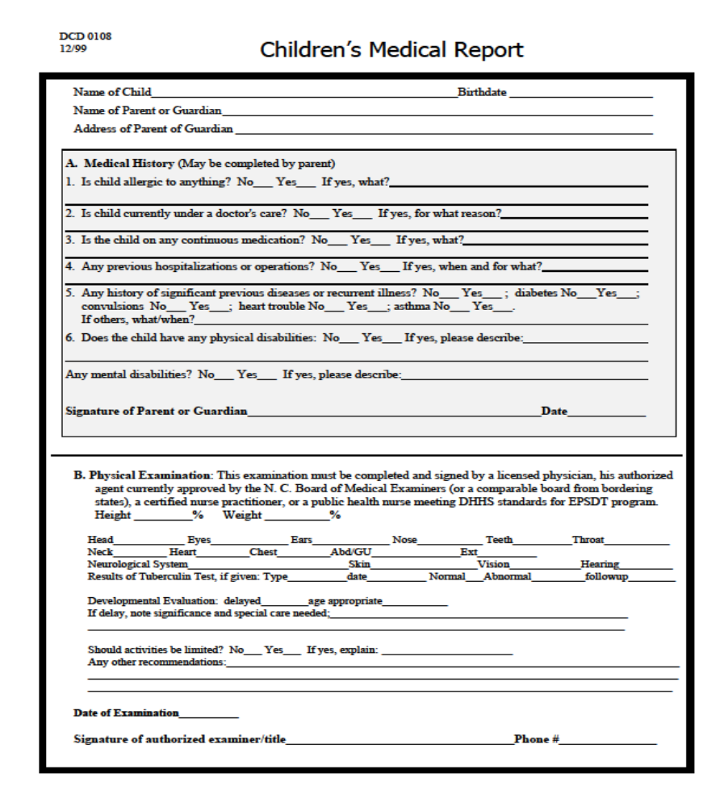

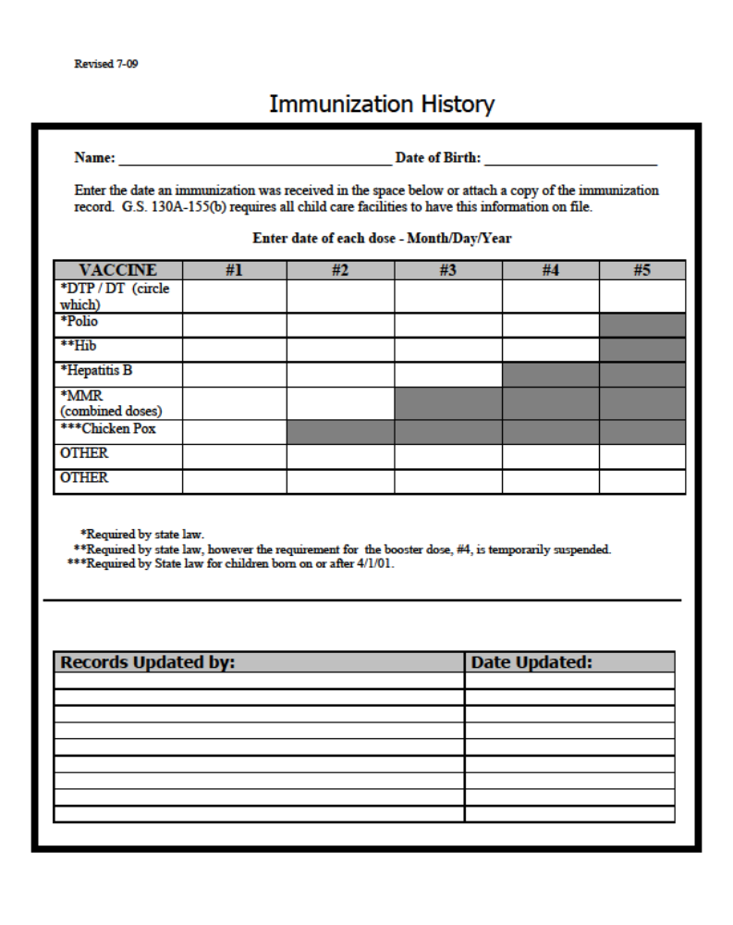

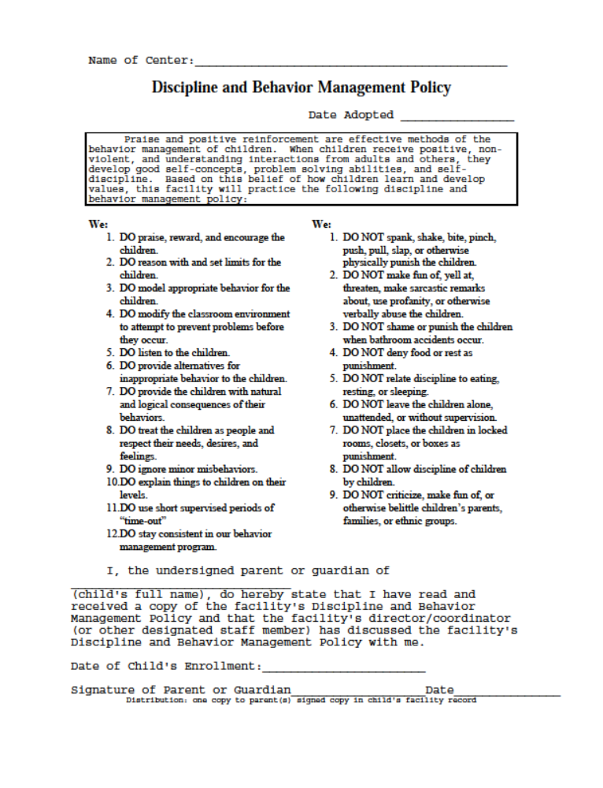

TRAVEL AND ACTIVITY AUTHORIZATION

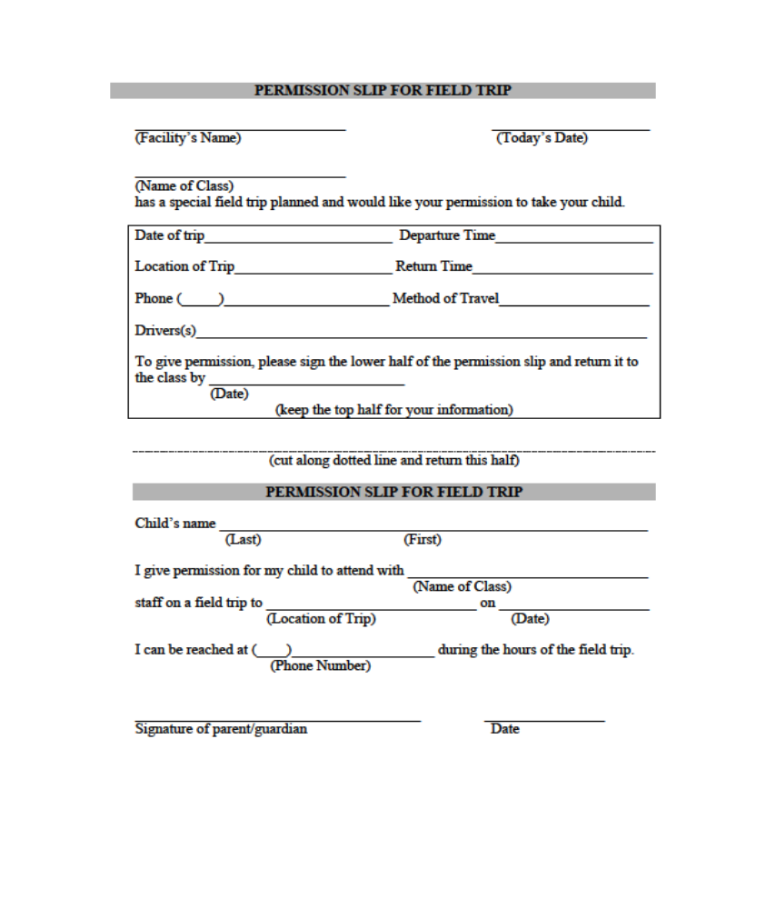

Receipt of Summary:
North Carolina Laws and Rules

I ________________________________ acknowledge that on _____________________
(Print parent or guardian name) (Date)

I received a copy of The Summary: North Carolina Laws and Rules:

________________________________ _____________________
(Signature) (Date)

The following requirements apply to both centers and homes.
Transportation
Child care centers or family child care homes providing transportation for children must meet all motor vehicle laws, including inspection, insurance, license, and restraint requirements. Children may never be left alone in a vehicle and child-staff ratio must be maintained.
Records
Centers and homes must keep accurate records such as children's attendance, immunizations, and emergency phone numbers. A record of monthly fire drills practiced with safe evacuation of children must also be maintained. A safe sleep policy must be developed and shared with parents if children younger than 12 months are in care.
Discipline
Each program must have a written policy on discipline, must discuss it with parents, and must give parents a copy when the child is enrolled. Changes in discipline policy must be shared with parents in writing before going into effect. Corporal punishment (spanking, slapping, or other physical discipline) is prohibited in all family child care homes and centers. Religious-sponsored programs which notify the Division of Child Development that corporal punishment is part of their religious training are exempt from that part of the law.
Parental Rights
• Parents have the right to enter a family child care home or center at any time while their child is present.
• Parents have the right to see the license displayed in a prominent place.
• Parents have the right to know how their child will be disciplined.
The law and rules are developed to establish minimum requirements. Most parents would like more than minimum care. Child care resource and referral agencies can provide help in choosing quality care. Check the telephone directory or talk with a child care provider to see if there is a child care resource and referral agency in your community. For more information, visit the Resources in Child Care website at: www.ncchildcare.net. For more information on the law and rules, contact the Division of Child Development at 919-662-4499 or 1-800-859-0829, or visit our homepage at: http://www.ncchildcare.net.

Reviewing Files
A public file is maintained in the Division’s main office in Raleigh for every center or family child care home. These files can be
- viewed during work hours;
- requested via the Division’s web site at www.ncchildcare.net; or,
- requested by contacting the Division at 1-800-859-0829.

How to Report a Problem
North Carolina law requires staff from the Division of Child Development to investigate a licensed family child care home or child care center when there has been a complaint. Child care providers who violate the law or rules may be fined up to $1,000 and may have their licenses suspended or revoked. If you believe that a child care provider fails to meet the requirements described in this pamphlet, or if you have questions, please call the Division of Child Development at 919-662-4499 or 1-800-859-0829.
Child Abuse or Neglect
Abuse occurs when a parent or caregiver injures or allows another to injure a child physically or emotionally. Abuse may also occur when a parent or caregiver puts a child at risk of serious injury or allows another to put a child at risk of serious injury. Neglect occurs when a child does not receive proper care, supervision, or discipline, or when a child is abandoned. North Carolina law requires any person who suspects child abuse or neglect to report the case to the county department of social services. In addition, any person can call the Division of Child Development at 919-662-4499 or 1-800-859-0829 and make a report of suspected child abuse or neglect in a child care operation. Reports can be made anonymously. A person cannot be held liable for a report made in good faith. The operator of the program must notify parents of children currently enrolled in writing of the substantiation of any abuse/neglect complaint or the issuance of any administrative action against the child care facility.

Summary:
North Carolina
Child Care
Law and Rules

Division of Child Development
North Carolina Department of
Health and Human Services
319 Chapanoke Road
Raleigh, NC 27603

May 2009



The North Carolina Department of Health and Human Services does not discriminate on the basis of race, color, national origin, sex, religion, age, or disability in employment or provision of services.

2,000 copies of this document were printed at a cost of $179.64 or $0.09 per copy.

What is Child Care?

The law defines child care as:
• three or more unrelated children under 13 years of age
• receiving care from a non-relative
• on a regular basis, of at least once a week
• for more than four hours per day but less than 24 hours.
It is only when all of these conditions exist that regulation is required. The North Carolina Department of Health and Human Services is responsible for regulating child care. This is done through the Division of Child Development. The purpose of regulation is to protect the well-being of children while they are away from their parents. The law defining child care is in the North Carolina General Statutes, Article 7, Chapter 110.

The North Carolina Child Care Commission is responsible for adopting rules to carry out the law. Some counties and cities in North Carolina also have local zoning requirements for child care programs.

Star Rated Licenses
Centers and homes that are meeting the minimum licensing requirements will receive a one star license. Programs that choose to voluntarily meet higher standards can apply for a two through five star license. The number of stars a program earns is based upon the education levels their staff meet and the program standards met by the program.

Family Child Care Homes
A family child care home is licensed to care for five or fewer preschool age children, and can include three additional school-age children. This includes preschoolers living in the home but the provider's own school-age children are not counted (Individuals caring for one or two children are exempt from being licensed.) Licenses are issued to family child care home providers who meet the following requirements:

• Home providers must be 21 years old with at least a high school education or its equivalent, and mentally and emotionally capable of caring for children.
• He or she must undergo a criminal records background check initially, and every three years thereafter.
• All household members over age 15 who are present in family child care homes when children are in care must also undergo a criminal records background check. As of December 2008, criminal records rechecks are done every three years.
• All family child care home providers must have current certification in CPR and first aid and complete an ITS-SIDS training every three years. They also must complete a minimum number of training hours annually.

All family child care homes must meet basic health and safety standards. Providers must maintain verification of children’s immunization and health status. They must provide developmentally appropriate toys and activities, as well as nutritious meals and snacks for the children in care.

Child Care Centers
Licensing as a center is required when six or more preschool children are cared for in a residence or when three or more children are in care in a building other than a residence. Religious-sponsored programs are exempt from some of the regulations described below if they choose to meet the standards of the Notice of Compliance rather than the Star Rated License. Programs that operate for less than four consecutive months, such as summer camps, are exempt from licensing. Child care centers may voluntarily meet higher standards and receive a license with a higher rating. Centers will be visited at least annually to make sure they are following the law and to receive technical assistance from child care consultants.

Licensed centers must meet requirements in the following areas.

Staff
The administrator of a child care center must be at least 21, and have at least a North Carolina Early Childhood Administration Credential or its equivalent. Lead teachers in a child care center must be at least 18 and have at least a North Carolina Early Childhood Credential or its equivalent. If administrators and lead teachers do not meet this requirement, they must begin credential coursework within six months of being hired. Staff younger than 18 years of age must work under the direct supervision of staff 21 years of age or older. All staff must complete a minimum number of training hours including ITS-SIDS training for any caregiver that works with infants 12 months of age or younger, and CPR and first aid training. All staff must also undergo a criminal records background check. As of December 2008, criminal records rechecks are done every three years.

Ratios
Ratios are the number of staff required to supervise a certain number of children. Group size is the maximum number of children in one group. Ratios and group sizes for licensure are shown below and must be posted in each classroom.

Age | Teacher : Child Ratio | Maximum Group Size
0-12 months | 1:5 | 10
12-24 months | 1:6 | 12
2 years old | 1:10 | 20
3 years old | 1:15 | 25
4 years old | 1:20 | 25
School-age | 1:25 | 25

Children may keep up to three additional school-age children, depending on the ages of the other children in care. When the group has children of different ages, staff-child ratios and group size must be met for the youngest child in the group.

Space and Equipment
To meet licensing requirements, there must be at least 25 square feet per child indoors and 75 square feet per child outdoors. Outdoor play space must be fenced. Indoor equipment must be clean, safe, well maintained, and developmentally appropriate. Outdoor equipment and furnishings must be child size, sturdy, and free of hazards that could injure children.

specific curriculum over another unless programs are using curriculum to get a quality point for the star-rated license. Child care programs choose the type of curriculum appropriate for the ages of the children enrolled. Activity plans must be available to parents and must show a balance of active and quiet, and indoor and outdoor activities. Rooms must be arranged to encourage children to explore and use materials on their own.

Health and Safety
Children must be immunized on schedule. Each licensed center must ensure the health and safety of children by sanitizing areas and equipment used by children. Meals and snacks must be nutritious, and children must have portions large enough to satisfy their hunger. Food must be offered at least once every four hours. Local health, building, and fire inspectors visit licensed programs to make sure standards are met. All children must be allowed to play outdoors each day (weather permitting) and must have space and time provided for rest.

HEALTH INFORMATION AND DEVELOPMENTAL HISTORY FORM

Child‘s Name ________________________________________ Date of Birth _______________________
Last, first day, month, and year

HEALTH INFORMATION
How many colds has your child had this past year? _______________________________________________
How does the child react to an elevated temperature? ____________________________________________
How does your child react to being ill? ________________________________________________________
Is diarrhea or constipation a problem? ________________________________________________________

PERSONAL HISTORY
Child’s Nickname ________________________________________________________________________
Language spoken at home (other then English) __________________________________________________
Names of Siblings? ______________________________________________________________________
Mother’s church membership? ______________________________________________________________
Father’s Church Membership? ______________________________________________________________
Primary caretaker of child? ________________________________________________________________
Previous childcare arrangements? ___________________________________________________________
Child’s reaction to these arrangements? _______________________________________________________

EATING
What time does your child usually eat breakfast? _________ Lunch______________ Dinner ______________
Is the child usually hungry at mealtimes? ____________________________ Between meals? _____________
What are his/her favorite foods? ___________________________________________________________
What eating problems does the child have? ____________________________________________________
Any food allergies? ______________________________________________________________________

TOILET HABITS
Can the child be relied up to indicate bathroom needs? ___________________________________________
Does the child need to go more frequently than usual for his/her age? _______________________________
Does he/she have accidents? ______________________________________________________________
How does he/she react to them? ___________________________________________________________

Does the child wet his/her bed at night? __________________ If so how often _____________________

SLEEPING
What time does the child go to bed? _________________________________ awaken? ________________
Does your child have sleep problems? ______________ If so what? ________________________________
____________ How are they handled _______________________________________________________
Does he/she take naps? ___________________ From ________________ to _______________________

SOCIAL REALTIONSHIPS

Will this be the child’s first real separation from parents? _____________________________________
Has the child been in preschool or daycare previously? ________________________________________ if so, was it a good experience? Explain ___________________________________________________
_________________________________________________________________________________
By nature is he/she □ friendly □aggressive □ shy □ withdrawn

How does he/she get along with brothers and sisters? _______________________________________
How does he/she get along with other adults? _____________________________________________
With what age child does he/she prefer to play? ___________________________________________
Do you feel he/she will adjust easily to the childcare situation? ________________________________
How does he/she relate to strangers? ___________________________________________________
How does the child show his/her feelings? ________________________________________________
Does your child cry easily? ____________________________________________________________
What makes him/her mad or upset? _____________________________________________________
Does your child have any nervous habits? ______________ If so what are they and how are they handled? ________________________________________________________________________________
Does your child have any behavioral problems? _________________ if so what are they and how are they handled _________________________________________________________________________
What do you use as the most effective mode of discipline? ____________________________________
Is he/she frightened by: □ Animals □tall people □rough children □loud noises □ storm □darkness □ other ________________________________________________________________________________
What are your child’s favorite toy(s), game, and activity at home? _______________________________
Does he/she prefer to play outdoors? ____________________________________________________
Can he/she ride a tricycle? ____________________________________________________________
Has he/she experience with □clay □scissors □easel painting □ finger-painting □ blocks □ water play

COMMENTS
How do you feel about childcare for your child? ___________________________________________
________________________________________________________________________________
Will you be able to participate in your child’s program? _______________________________________
What would you like to see us provide for your child? _________________________________________
Is there anything else we need to know in order to take better care of your child? __________________
_________________________________________________________________________________

____________________________________ ________________
Parent signature date

____________________________________ ________________
Parent signature date

DISCIPLINE PROCEDURES

Body of Christ Christian Church Preschool desires to create an environment for children that are sup portative and respectful of their needs. We do not view discipline as punishment but corrective, and we will give children the freedom to make mistakes and learn from them. Our goal is to help each child develop a strong sense of self –discipline and self-esteem. Our teacher swill set guidelines for each classroom that will be reinforced in a consistent and loving way. Positive reinforcement will be used to encourage desired behaviors.

When a child needs correction for inappropriate behavior the following steps will be implemented until problem is resolved:

Step 1 Depending on the situation, a verbal warning will be given and the child reminded of acceptable behavior
Step 2 The teacher will use redirection from the inappropriate behavior or activity to a more constructive use.
Step 3 The teacher will talk to the child and explain the infraction and consequences for it (both to child and others), giving the child the responsibility to choose for him/herself by restating the rules.
Step 4 A “time out” procedures will be followed. This timeout is not punishment, but s time when the child can calm down, regain control of him/herself, remember what behavior is acceptable, and decide when they are ready to join the group.

- Time out consists of separating the child from the group for 3 to 5 minutes at the maximum, at which time the teacher will reinforce step 3 adding new consequences.
Or
The child will have to change the color on their card or whatever object they are using to reflect what color the child is on in direct correlation to their behavior. The colors the children use are:

Green: behavior is at its best.
Yellow: behavior needs to be redirected. A child may be given several attempts at yellow before color is moved to the next color.
Red: Attempts at redirection have been deemed ineffective and a punishment has to be given out or a note home to reflect the negative behavior(s).
Purple: purple is our special color that is given to those students whose behavior has been exceptional at which time a special prize or privilege will be given to the students.

If a child does not respond to positive reinforcement:

- The child will be sent to the director for additional time-out
- The child’s parents will be contacted to arrange a conference with teacher and director
- Program will recommend professional help to assist the family. It they refuse help we will ask that the child be withdrawn from the program.
- The child will be removed for severe and/or repeated behavioral problems.

AT NO TIME will we use corporal punishment or physical punishment, shaming, yelling, or anger to gain desired behavior. We will not place children in locked rooms or closets, withhold food, rest, or toilet privileges from them, or allow one child to discipline another. Furthermore, we will not punish children for lapses on toilet training or accidents (spilling juice, bumping into someone unintentionally etc.)

I, _____________________________________________, have read the Discipline Policy of Body of Christ Christian Church Preschool and understand the guidelines set forth in this document. Furthermore, any questions I have regarding this policy have been discussed with the director.

Child’s Name ____________________________________________ Date Enrolled ____________________

Parent/ Guardian __________________________________________ Date ___________________________

Director _________________________________________________Date ___________________________

PARENTAL SUPPORT & AGREEMENT FORM
We, at Body of Christ Christian Church Preschool (BOCCP) strongly urge parents to make a commitment to volunteer in their child’s classroom. Parental support is a vital part of the success and effectiveness of our program. Your child will also benefit when you participate. Please take some time to prayerfully consider how you can support BOCCP. Parents are asked to volunteer once a month or more if possible. Below are some ways your can be involved, please check any item in which you can volunteer your time.
□ I would be willing to help with special events and activities (parties, programs, Field Day)
□ I would be willing to be a parent volunteer in field trips.
□ I would be interested in finding our more about being a Room Parent
□ I will attend Parent Teacher conferences or send a family representative
□ I will be willing to attend Parent-Education Workshop.

Body of Christ Church Preschool shall provide care for __________________________________________
(Child’s name)

I agree to cooperate with the general policies of Body of Christ Christian Church Preschool to perform the obligations of parents or guardians set forth in this agreement, and to abide by the rules, regulations, and policies set forth in the Body of Christ Christian Church Preschool Parent Handbook. My signature below indicates that I have read the terms of this agreement and that I have read the rules, regulations, and policies outlined in the Handbook. It further indicated that all my questions in regard to the Handbook this agreement and policies of Body of Christ Christian Church preschool have been satisfactorily answered. What is more, having signed this agreement, I understand that any violation of this agreement or the policies in the handbook on my part can result in the removal of my child from this program.

_____________________________________________ _____________________________
Parent/Guardian Date

______________________________________________ ______________________________
Parent/Guardian Date

______________________________________________ ______________________________
Director’s Signature Date

PHOTOGRAPH CONSENT FORM

I, hereby give Body of Christ Church Preschool permission to photograph my child _____________

___________________________________________________ for school purposes. I further understand (Child’s name)

That these pictures may be used in the future for school or church advertisements on our website, church flyers, newspaper or other forms of advertisements

___________________________________________________ __________________________
Parent/Guardian Signature Date

___________________________________________________ ___________________________
Parent/ Guardian Signature Date

MISSION STATEMENT

Body of Christ church preschool seeks to serve as an extension of the family by providing a sound biblical and exceptional academic education for all children, preparing them to be outstanding citizens in the kingdom of God

( ) Yes ( ) no Do you understand and agree with the mission statement? ( ) Yes ( ) no Will one parent attend parent-teacher relationships?
I/We certify that the above answers are true and are made with no reservations.

__________________________________________________ ________________ Parent/Guardian Signature Date

What to bring on the first day of preschool

- All children are required to bring cover for naptime. Sheets are required of all students for sanitary purposes and blankets and pillows are highly suggested for student comfort. Please bring small travel sized pillows, blankets and cot-sized sheets due to limited space. Please label all items
- All children are required to bring a change of clothes. Please label all items that the children bring to preschool and if possible have them in a Ziploc bag.
- A completed application is required for students prior to their first day of preschool to include the following items:
  - Child’s shot record
  - Child’s physical examination
- All fees must be paid prior to the first day of preschool.

